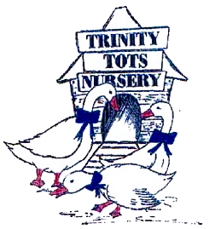
Trinity Tots Nursery
Multiple Birth Families Policy
UNCRC Articles: 1, 2, 3, 5, 8, 12, 13, 16, 28, 29

At Trinity Tots Nursery we ensure that all families are included and supported fully, no matter how big or small. There are more multiple births occurring in the UK, twins, triplets and even more. As a nursery, we accommodate all families and work together with parents to ensure all children are treated as individuals and supported to make the best progress they can.
This policy should be read in conjunction with our Settling in policy and Partnership with Parents policy. In addition to these, to support the needs of multiple birth families, we will:
- Acknowledge multiple birth relationship as special and to be celebrated as well as encouraging children to develop as individuals
- Work with parents to explore each child’s individual preferences, interests, needs and starting points including, where applicable, ways for staff to identify them apart
- Complete individual forms for each child to discover their individual routines, specific requirements, dietary needs etc.
- Recognise and celebrate all individual achievements
- Report back on each child separately at the end of the day to the parents
- Consider separation if this is beneficial for their development. Parents, and where appropriate the children, will be involved in the decision for when, where and how this may occur (e.g. focused activities, outdoor play)
- Arrange parental consultations for each child. Each child will receive the same time during the consultation as any other child in the setting. Assessments will be shared based on their individual progress and comparisons between the children will not be made. Any concerns will be discussed as per our ASN policy
- Understand that each child is unique and not expect them to behave in the same manner, excel in the same areas or enjoy the same activities

This policy was last reviewed | Signed on behalf of the nursery | Date for review
17th March 2026 |  | March 2027

