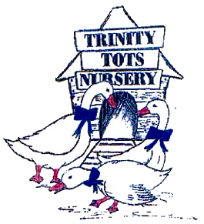
Trinity Tots Nursery
Equipment and Resources Policy
HSCS: 2.27, 5.16, 5.21, 5.22

At Trinity tots Nursery we organise the premises and equipment to meet the needs of all the children. We provide a wide range of high-quality equipment and resources to support the delivery of our early years’ curriculum. We take reasonable steps to ensure the safety of children and minimise the risks they are exposed to.

To ensure this occurs within the nursery including in our outdoor areas, we will provide:
- Play equipment and resources which are safe and, where applicable, conform to the European Standards for Playground Equipment: EN 1176 and EN 1177, BS EN safety standards or Toys (Safety) Regulation (1995)
- Enough equipment and resources for the number of children registered in the nursery.
- High quality resources to meet children’s individual needs and interests and promote all areas of children's learning and development.
- Opportunities to involve the children in decision making about new resources and equipment, where possible
- A wide range of books, equipment and resources which promote positive images of people of all races, cultures, ages, gender and abilities, are non-discriminatory and do not stereotype.
- Play equipment and resources which promote continuity and progression, provide sufficient challenges and meet the needs and interests of all children.
- Sufficient storage so resources and equipment can be displayed for children to independently choose and/or are stored away safely and then rotated
- Appropriate risk assessments and checks on all resources and equipment before first use to identify any potential risks and again regularly at the beginning and end of every session
- Clean and maintained resources and equipment. We repair or replace any unsafe, worn out, dirty or damaged equipment whenever required
- An inventory of resources and equipment. This records the date on which each item was purchased and the price paid for it
- An evaluation of the effectiveness of the resources including the children’s opinions and interests
- Adults who role model and have discussions with the children to ensure that they respect the equipment and resources and encourage them to be put away where they belong after use. We will often use pictures to support the children to do this.

This policy was last reviewed | Signed on behalf of the nursery | Date for review
6th March 2026 |  | March 2027

