The Purpose Of A Communication Friendly Nursery

- Communication should be as easy, effective and enjoyable as possible.

- Everyone should have opportunities to talk, listen and take part.

- Learning and social development are supported through opportunities to communicate

- Everyone’s communication skills are supported but especially those of children with Additional Support Needs and English As An Additional Language

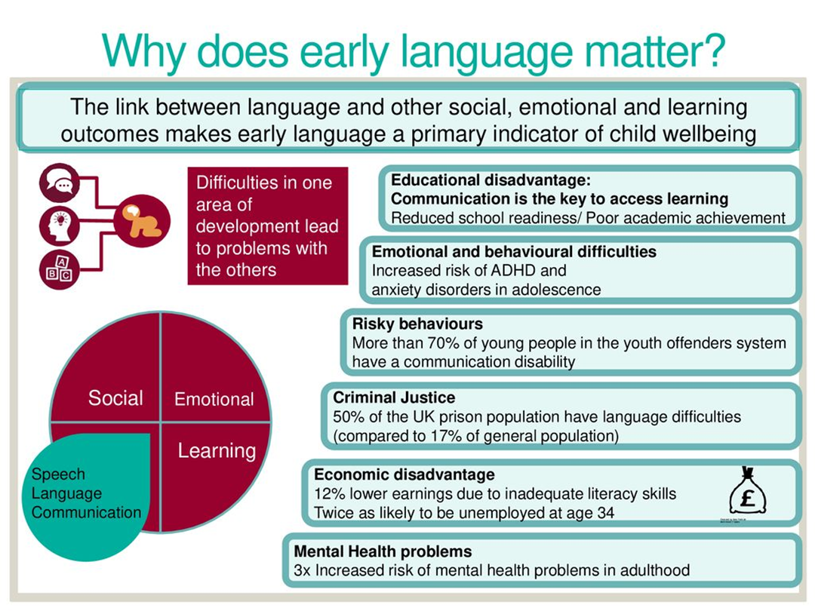

The Total Communication Approach

Total Communication is an approach which includes all the ways we communicate:

- Eye Contact
- Facial Expression
- Body Language
- Vocalization
- Hearing
- Touch
- Smell
- Taste
- Speech
- Symbols
- Photos
- Drawings
- Objects
- Written word
- Art
- Music
- Contextual clues
- Signs and gestures

Everyone communicates using at least one of the ways mentioned above. We all communicate in different ways and each way should be equally respected and encouraged.
Many individuals experience difficulties with communication, but there are many key things we can do as communicators to facilitate the process and make communication easier. Building a total communication environment means making subtle and simple changes to our communication and environment so that we can improve interaction and understanding.
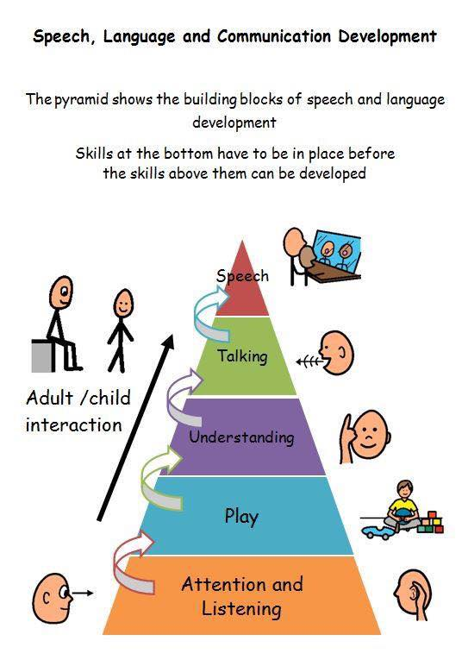
Top Tips for a Total Communication / Communication Friendly Nursery
1. Consistency – we must be consistent in the way we communicate with our children. It is important to all use the same form of communication when communicating with certain individuals.
2. Signing systems – where possible give the sign (or gesture) as well as the spoken word, this doubles the impact of the message, making it easier to understand.
3. Access – put pictures and objects in places that are accessible – both for reach and visually.
4. Language level – remember, if an individual has an understanding at a one-word level – use one word. Long sentences containing lots of information will be wasted. If you use more than one word, back it up with a visual, or a sign or gesture. Be aware and remember to pitch your language at a level that the listener will understand and give them plenty of time to process the information.
5. Questions – know when to use open and closed questions (closed question requires a short answer, often “yes” or “no”, open questions seek longer answers).
6. Give time to process, understand and respond – some children with Additional Support Needs or English as an Additional Language may need up to 10 seconds or more to process a message (count silently in your head).
7. Eliciting language – you cannot force a response. Asking a child to say a word does not mean they understand what they are saying. It is better to put language in, than try and pull it out. Provide opportunities for a response e.g. talk about what the child is doing, expand on their language, start a sentence but let them finish it.
8. Adaptation – if you are not being understood, be flexible, adapt your message. Change the language or complexity of language. Change the mode of communication – e.g. from verbal to picture. Give the chid other ways to respond – symbols, sign, gesture etc. Give them more time to process. Change your goals if things are not working.
9. Use your body and face – use body language and gesture, use your facial expressions, they all lend weight and cues to your message.
10. Face to face – make sure you are facing the person, be at their level and look at the person you are communicating with.
11. Use texture and objects – in their simplest form, textures or objects can be used to give individuals an idea of what is about to happen e.g. give them a spoon and they know its time for lunch, or a towel before going swimming etc.
12. Use environmental cues – use the cues that are all around us and build on them. They can include pictures, logos, colours, noise and texture.
13. Use pictures and visuals – Visual strategies can be used in a multitude of ways to enhance understanding and expression.
14. The environment – it is important to create an environment that is conducive to communication. Provide good lighting and reduce background noise or distractions.
Objects of Reference
What are Objects of Reference?
Objects of Reference are objects that are used to communicate meaning in the same way as words and pictures. They can be used to represent anything we want to communicate: people, places, activities, events etc. For example, a cup can stand for a drink. Objects are concrete and permanent and offer lots of sensory information. They don’t rely on processing verbal information or memory.
You are likely to be using everyday objects with the children you care for already. You may be saying to them “we are going out” while handing them their shoes, thereby giving them a visual clue as to what is going to happen, so they don’t need understand all the words you are saying. Objects of Reference are objects that are used in a structured and consistent way and used every time the activity etc is going to happen. An object becomes an Object of Reference when the child begins to associate it with the activity it represents.
The objects need to be carefully selected and used in situations where the need to communicate exists.
• They need to be meaningful to the child. A simple link or a strong association between object and activity/person is best. For example, a nappy stands for nappy changing; a plate stands for lunch. However, what might seem a clear link to you may not be for the children. Spend time observing them doing the activity before choosing an object.
• Start with a few objects that represent activities/events that occur frequently. Repetitions of use will make it easier for the children to understand the connection between the object and its meaning.
• It is vital that there is a consistency of approach. Everybody will need to introduce the object in the same way, using the same keywords and signs. Written guidelines are essential.

How Do Objects of Reference Help With Communication?
A lot of the time things just ‘happen’ to babies/toddlers. Objects of Reference let them know what is about to happen and help understand what is being said.
Once the objects become objects of reference the children can begin to use them themselves to ask for activities and make choices. Objects can be used in the form of a timetable, so the children can begin to predict the events of the day.

Within Trinity Tots Nursery
Objects of Reference are used to support activities in the Bumblebee Room.
Visual Timetables

What Is A Visual Timetable
A Visual Timetable uses photos, pictures, symbols or objects placed in a sequence to represent daily activities. They show the user what is happening and can represent part of the day, a whole day, week or month.

How Does A Visual Timetable Help With Communication?
A Visual Timetable gives children more control and predictability over their daily life. It can give them opportunities to make choices and encourage communication.
It can help children who do not understand the concept of time. A picture of key routines such as breakfast, lunch and hometime can be permanent and used every day. The spaces/boxes in between can be filled daily to show activities, tasks etc. For example, it can show that on Monday after breakfast they will go for a walk and after lunch, they will be going recycling. On Tuesday after breakfast they go shopping and after lunch, they do gardening.
A timetable can help by showing ‘waiting’. Waiting for something to happen can be difficult for some children causing great frustration. A timetable can show that they have to do certain activities before they get to do the activity they want to.
The pictures can be used to explain things that are not happening .If an activity has been cancelled the corresponding picture can be removed or covered over.

Within Trinity Tots Nursery
Visual timetables are present in every room.

Signalong

What Is Signalong?
Signalong is an approach to teaching communication, language and literacy using combined modes of communication. It is not a language in its own right. Signalong is a key word sign-supported communication system based on British sign language and is used in spoken word order. It uses speech, sign, body language, facial expression and voice tone to reference the link between sign and word.

How Does Signalong Help With Communication?
The Signalong signs and symbols provide extra information to speech which is visual. This assists children’s understanding of language and supports their expression. It enables those children with communication difficulties and their carers to have a ‘shared language’ of key words around daily living.
Using the signs and symbols together with speech can prompt children to develop their verbal and literacy skills. Research has shown that signs/ gestures are easier to learn than spoken words. In using Signalong, children are able to develop important communication skills.

Within Trinity Tots Nursery
Staff use Signalong symbols to support the spoken word and undertake regular training to expand their signalong vocabulary.

Talking Mats

What Is A Talking Mat?
A Talking Mat is a low-tech communication framework designed to assist people with communication difficulties to express feelings, choice, or arrive at a decision. A talking mat uses a three point “visual scale” (can be less or more) placed at the top of the mat, and a “topic” which is placed at the bottom. “Options” are offered one at a time to the child and they can place them on the mat to indicate their general views.

How Do Talking Mats Help With Communication?
A child does not need speech to use a Talking Mat and therefore it can give them a voice. The tool also supports comprehension, as it gives information to someone in different ways i.e. – in a visual way, in a tactile way and also through auditory channels. As Talking Mats uses a simple structure, it gives a person time to process what is being asked, organise their thoughts and then respond with what they feel in a visual way.
Photographs, pictures or even objects can be used and therefore a mat can be tailored to the child’s level of understanding. A permanent record of the child’s opinions, choices etc can also be made by taking a photograph of what they have said. This helps the child to feel that their views are valued and will be remembered.

Within Trinity Tots Nursery
Practitioners use Talking Mats with children regularly to support their communication.

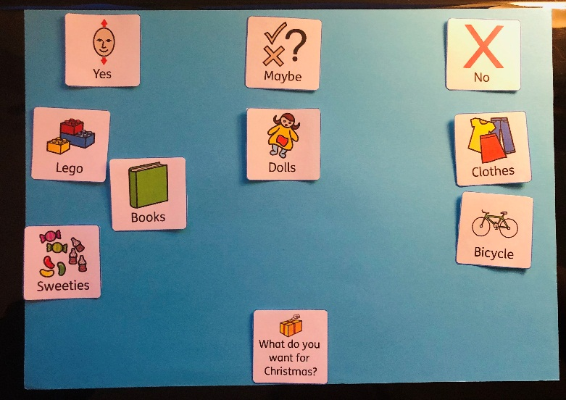

Symbols

What Are Symbols?
We are all familiar with symbols as they are used commonly in everyday life, in signs, instruction manuals, washing labels etc.
Symbols are not pictures, which may show lots of information and the focus may be unclear. Instead, symbols focus on a single concept. They can look like the concept that they are depicting or be more abstract.
Examples of this in everyday life are: the no smoking sign which looks like what it is depicting and the tumble drying sign which is more abstract.

How Do Symbols Help With Communication?
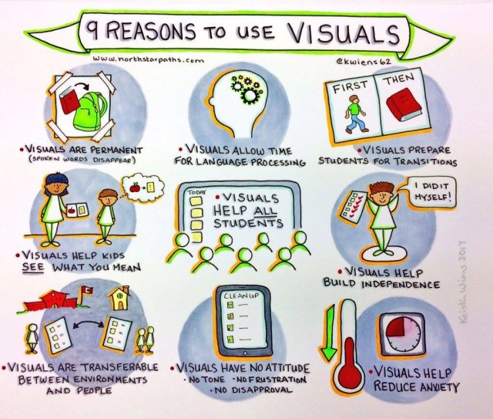
Task Aids

What Are Task Aids?
Task Aids are visual reminders of what you are going to do. They are guides that show the user what steps they will need to take in order to complete a task. The tasks can range from washing hands to baking a cake.
Task Aids can be made using photographs, pictures, symbols or on a single laminated sheet or in the form of a booklet, showing each step on a different page. Objects can be used in the same way. The objects needed for a task can be place in order or on a tray to show what needs to be done one step at a time.

How Do Task Aids Help With Communication?
A Task Aid will break a task down into easily to manage steps and reduce the need for prompting and input from others. A Task Aid visually communicates what needs to be done. It is a permanent record and does not rely on the understanding and processing of language or memory.
A Task Aid can increase:
• understanding;
• independence;
• participation;
• predictability
• consistency
• self esteem

Within Trinity Tots Nursery
You will see task aids used throughout the nursery to support children’s understanding of their daily routine with us.

Social Stories

What Is A Social Story?
A Social Story is a short story written in a specific style and format. The story describes what happens in a specific social situation, that may be obvious to us but not to people with impaired social understanding. It aims to improve the child’s understanding of social situations and encourage appropriate responses.
Social Stories use 3 types of sentences:
- Descriptive
- Perspective
- Directive
These need to be balanced carefully. Gray (1994) recommends a ratio of 0-1 Directive sentence to 2-5 Descriptive or Perspective sentences. Each story is unique and written for a specific child about a situation they find difficult and must include their name and preferably their photo as well.
Social Stories can use a mix of writing / pictures / symbols to match the understanding / language / vocabulary levels of the child.

How Do Social Stories Help With Communication?
Social Stories provide accurate information about real and relevant situations. They present information visually and do not rely on interpersonal contact. They are a prompt about how to respond and what to expect in a specific situation. They have clear goals and give reassurance and positive feedback.
Social Stories are often used to develop appropriate behaviour:
• They describe what people do.
• Why they do it.
• What are the common responses.

Within Trinity Tots Nursery
Social stories are used throughout the nursery to aid children’s understanding of situations.

